**Programming for Design – Semester 2, 2019**

**Assignment #2**

U3189931 - Kiandra Alston

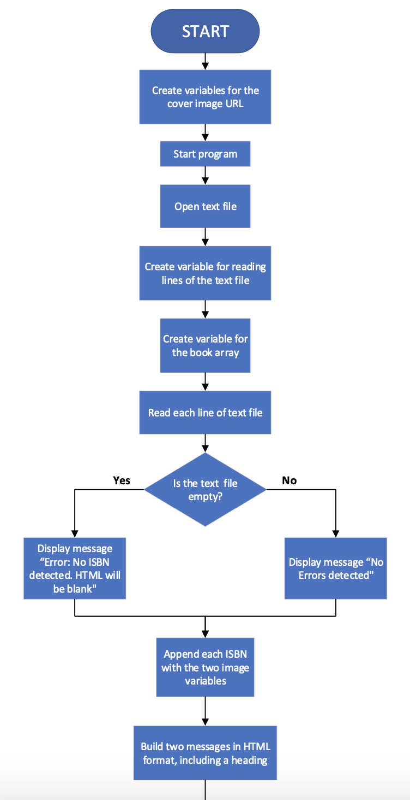Flowchart

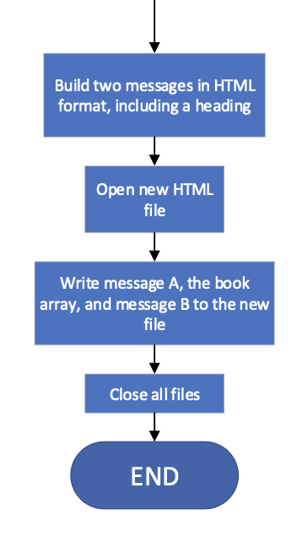Flowchart – Continued

**Comment**: The process “Build two messages in HTML format, including a heading” does not occur twice in the flowchart, it appears twice in this document to make the flowchart more readbale from each page.

Pseudocode

Create variables for the URL of the images

imageA = "<img src='http://covers.openlibrary.org/b/isbn/"

imageB = "-M.jpg' />"

START PROGRAM

Open text file in read fomrat

OPEN “./ISBN.txt”, “r”

Create a variable for reading the lines of the text file

fline = f.readlines()

Create a variable for the book array

Book_array = []

Read each line of the text

FOR xlines in the text file:

Is the text file empty? Do a check. If the file is empty print an error message and state that the HTML will be blank. If the file has content print a message indicating no errors were detected.

IF xlines is None:

Print ("Error: No ISBN detected. HTML will be blank")

ELSE:

Print ("No errors detected")

Append each ISBN from text file with images A and B

Book_array.append (imageA + xlines + imageB)

Write the two messages in HTML format, including a heading

messageA = <html><head>Book Information </head><body><p>

messageB = </p></body></html>

Open new HTML file in write format

OPEN “Webpage.html”, “w”

Write messageA, the book_array and messageB to the new HTML file, using variable ‘h’

h.write (messageA)

FOR books in book_array:

h.write (books)

h.write (message)

Close all files

CLOSE text file

CLOSE HTML file

END PROGRAM

**Comment**: In my code, I tried to write the check to see if the text file has IBSNs inside, however I receive an error whenever I run the code in the module. I do not understand what is wrong with ‘Print (“No errors detected”)’, but the code won’t run because of it. Other than this, the rest of the code should work. If you would like to see it work, simply remove this check from the code:

IF xlines is None:

Print ("Error: No ISBN detected. HTML will be blank")

ELSE:

Print ("No errors detected")

Code

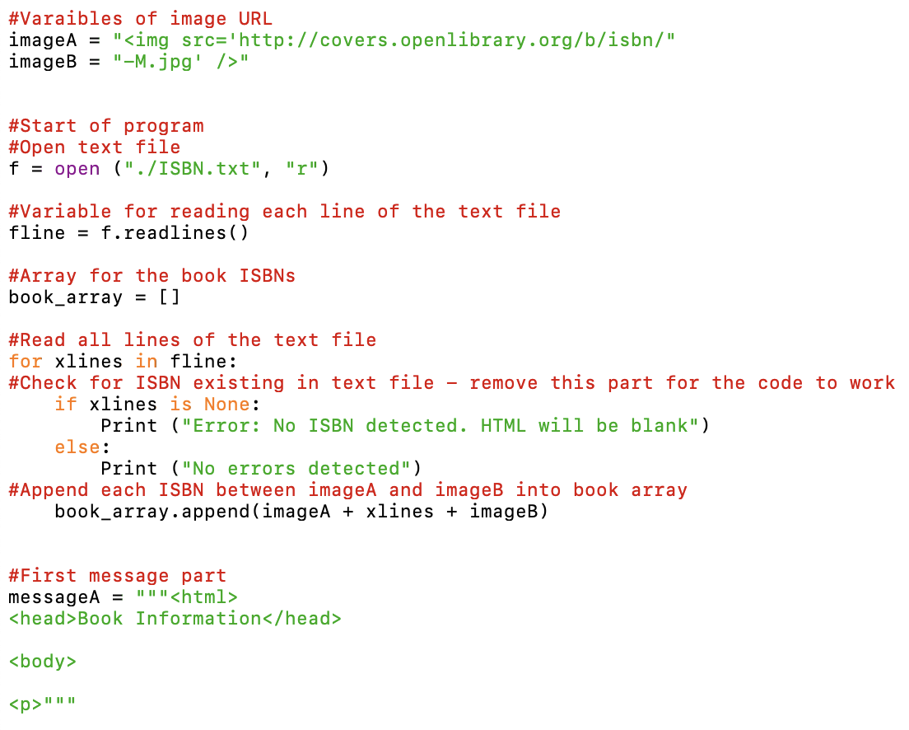

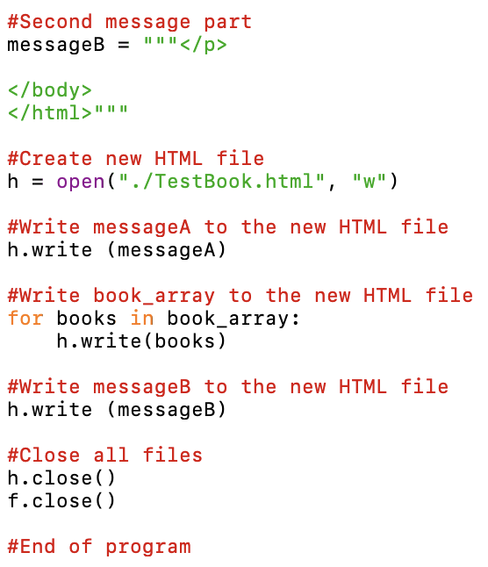

What I’ve Learnt

This unit has been my first introduction to programming and has opened my eyes to the creativity and potential of the different programming languages, how different methods can be used to achieve the same result and what works well together. Learning how much goes into designing even a HTML file has given me a lot of respect for programmers who design much more complex systems and files. I initially found the content challeneging as it was very alien to me, but as more exercises were done using the concepts of loops, do while loops, do loop whiles, arrays, functions, objects and more, I found it easier to understand how everything worked. I’ve also realised how important it is to do testing and think of ‘what ifs’ in terms of what could go wrong, errors in the code and the wrong input of a variable. I picked up JavaScript more easily than Python, however this could have been due to less time spent on the latter. I still find myself struggling to grasp certain concepts in Python, which made this final assignment very challenging to me. However, I’m sure with time I’d be able to wrap my head around it. Overall, I enjoyed the unit and feel knowledgable enough to now be able to speak to a programmer and understand what they mean when they talk about coding.